Assignment advanced sql data analysis

1 Create a query to select all columns from heroes_information but to add a new column called human. Have that column be a 1 if their race is Human and 0 if not.

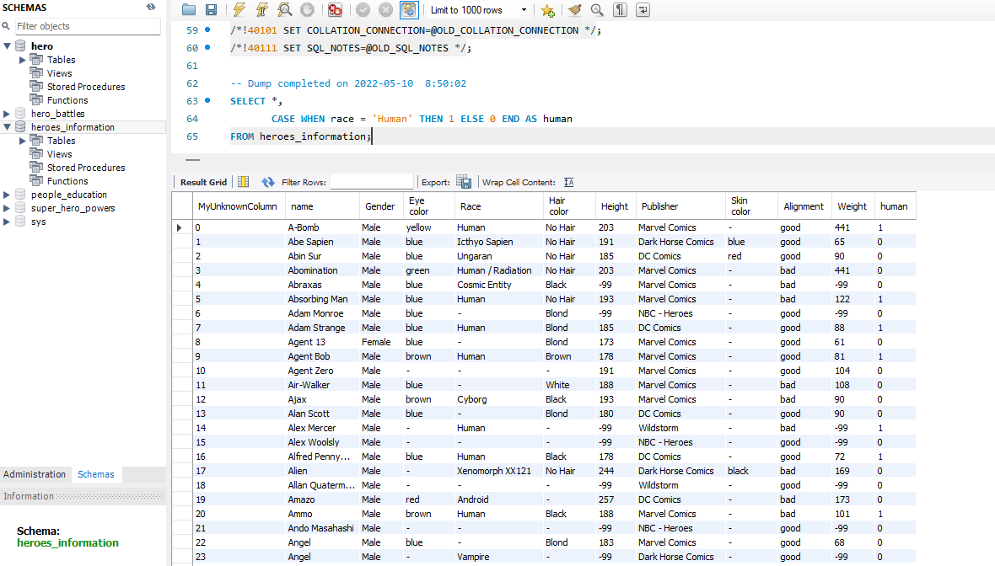

2 Create a new query to provide a list of the heaviest super heroes, with the heaviest being #1.

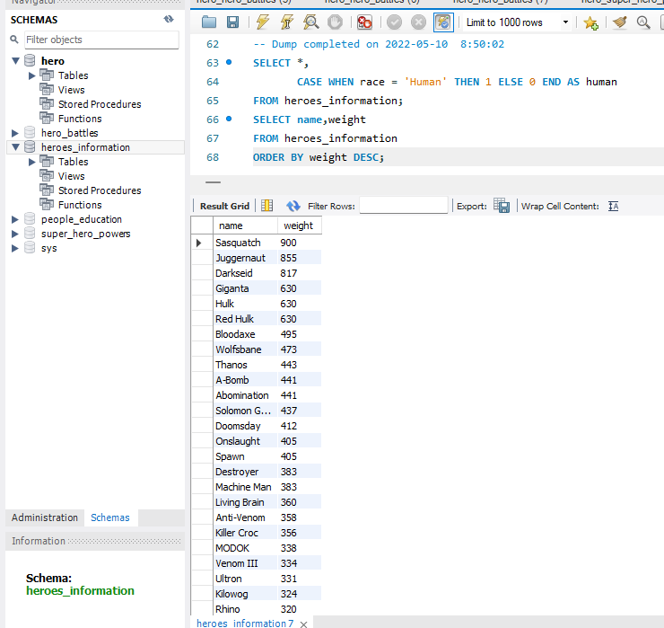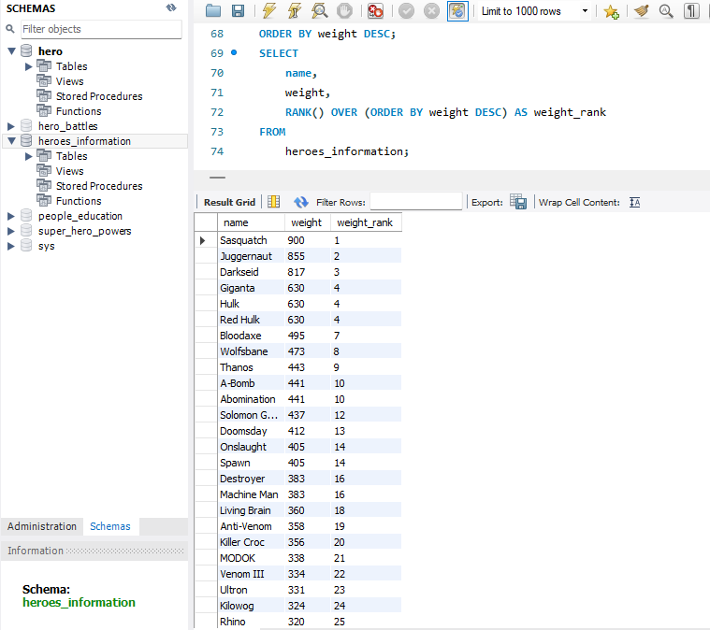

3 Give a frequency table with each letter of the alphabet and how many superheroes’ names start with that letter.

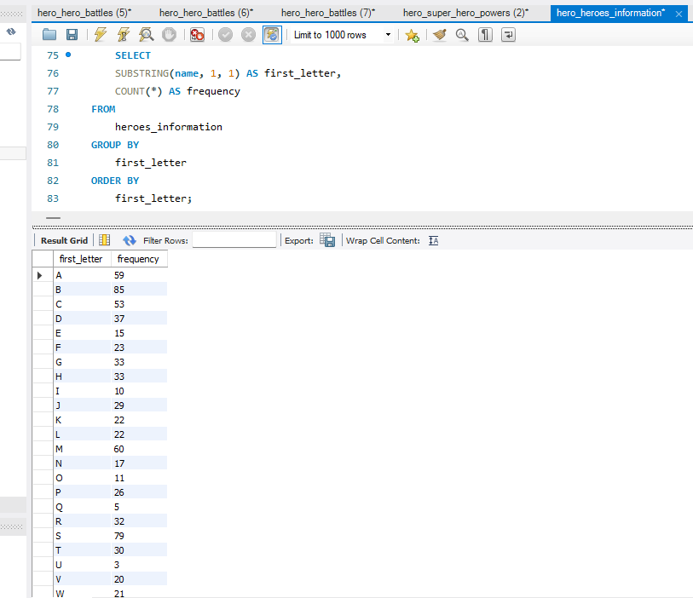

4 Select all the hero races with an average weight of over 150 and an average height of over 100.

